# Access outlook mails with proper endpoints:

**Step 1**: Login to Azure portal and search app registrations as shown below.

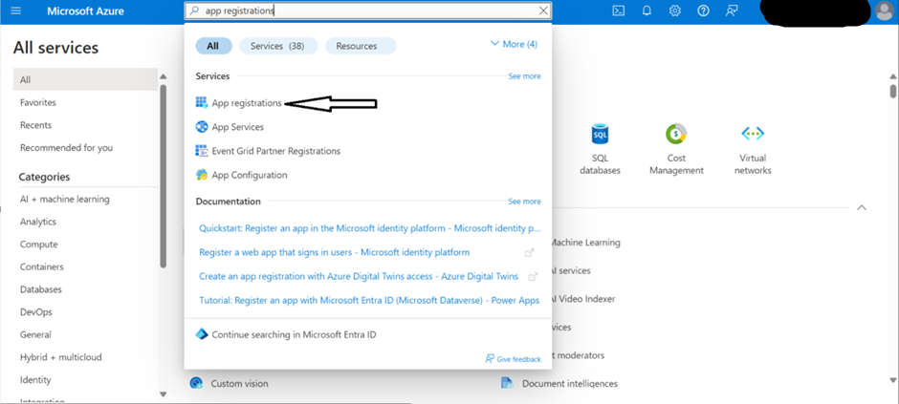

**Step 2:** Click on New Registration as follows:

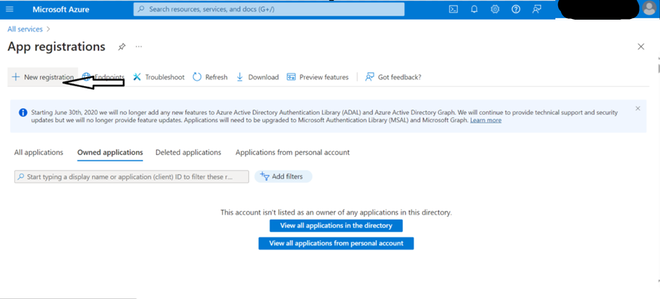

**Step 3:** Provide a name to the app and add a redirect URL to register the app as shown in below screenshots.

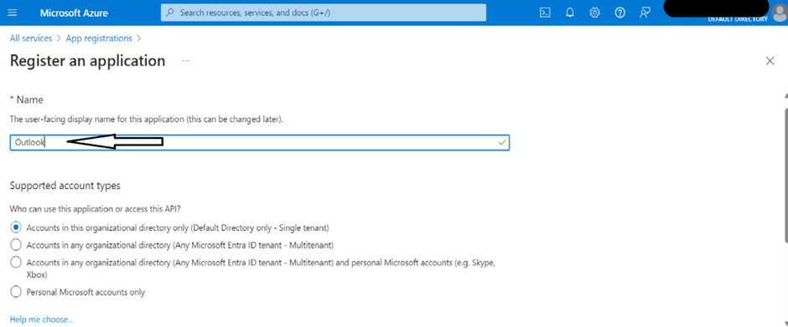

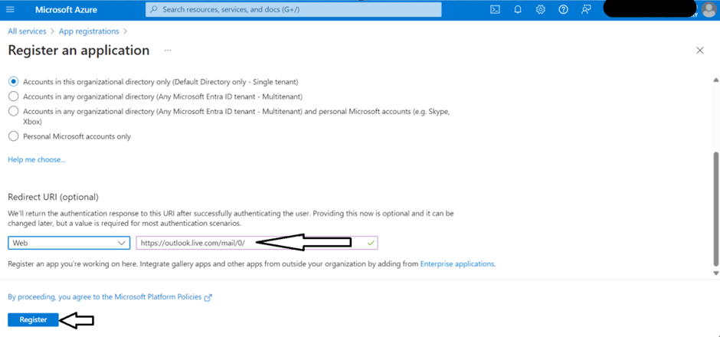

**Step 4:** After successfully registering the app, it appears as follows and copy the client ID as shown below:

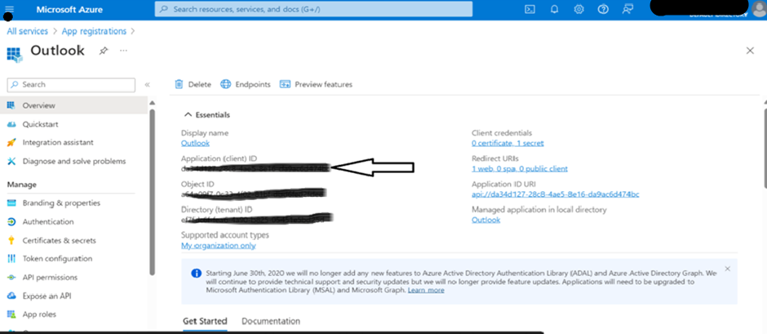

**Step 5:** Navigate to “Certificates & secrets” section and generate a “New client secret”. Copy the secret value for further usage.

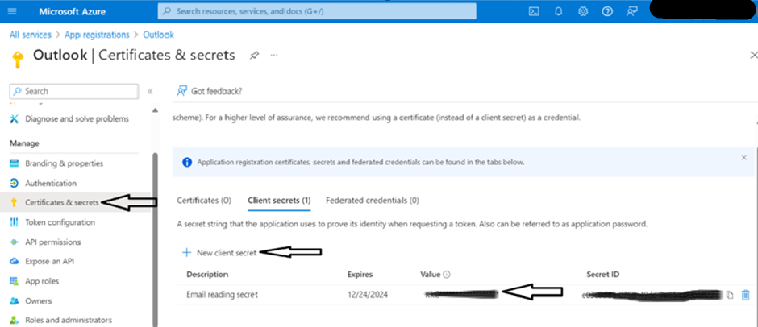

**Step 6:** After successfully registering the app, assign the required permissions to access the mails. To assign proper permissions, click on API permissions and add a permission as shown below:

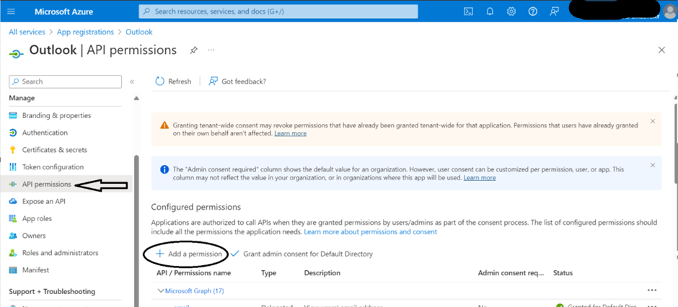

**Step 7:** Click on “APIs my organization uses” and select “Office 365 Exchange online” api as shown below.

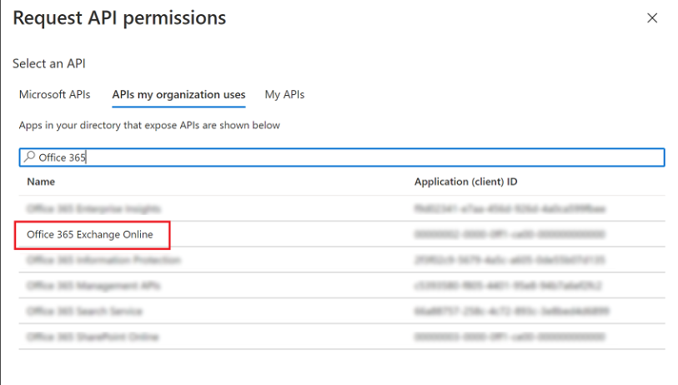

**Step 8:** Make sure below permissions are properly added and “grant admin consent for default directory” for the required permissions.

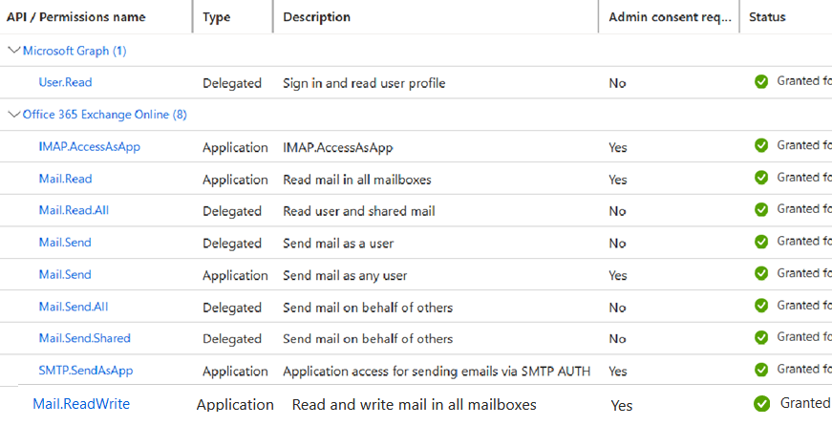

**Step 9:** Navigate to endpoints section from the overview and copy the “OAuth 2.0 token endpoint(v2)” to generate the access token.

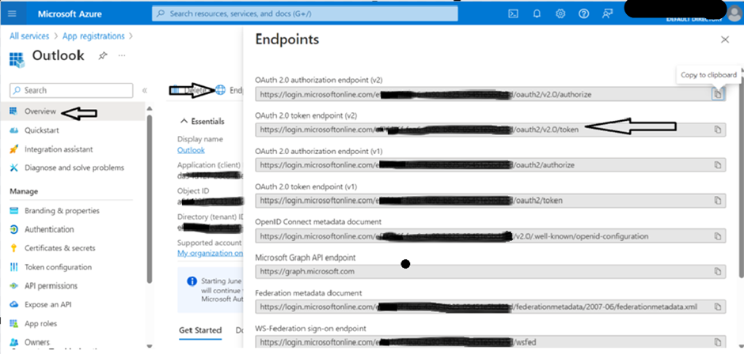

# Validation:

Verifying if generated keys are working properly or not.

**Step 10:** Paste the endpoint in the postman by passing the following parameters in the body. Use the client_id and client_secret from step 4 & 5 and pass these parameters in “x-www-form-urlencoded” format. Copy the generated access token to read the messages from mail.  
Make sure you replace the masked value in the endpoint with your tenant ID.

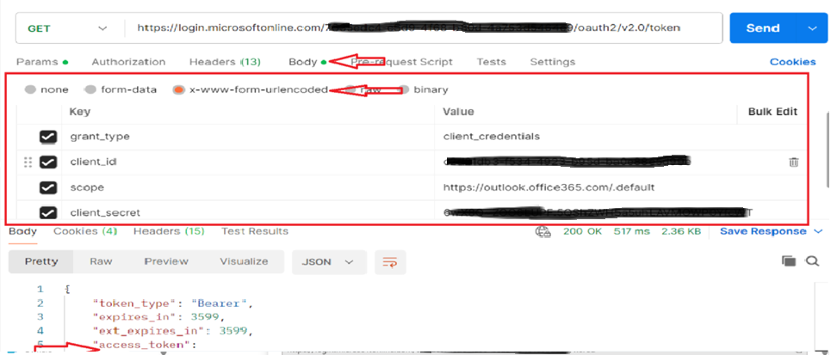

**Step 11:** Access the messages from the following endpoint by passing the access token generated in step 10 as a bearer token. Replace the email id with you emailed.

Replace the masked value in the endpoint with your email ID.

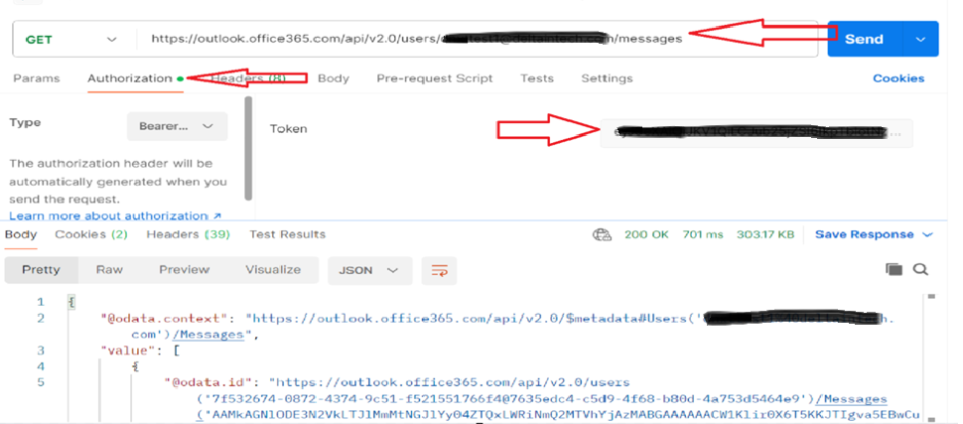

**Step 12:** Access the attachments in the mail by passing the required message id in the above endpoint.

Replace the masked value in the endpoint with the message id that which you want to access the attachments.

